Visco-Elastic Behaviour
Following the installation of the ICE prize winning RoadCem soil piling mats at Severn Trent Waters £45 million Cay Mills STW at Burton on Trent. PCT and Delft University of Technology, carried out simulation testing to explore and understand the dynamic force absorption properties observed on this project.
This visco-dynamic behaviour is a significant added value for construction design and shows that the stabilisation could bear high intensive dynamic forces such as the driving of piles through the RoadCem stabilisation. With no cracks occurring in the direct periphery of the piles nor in the complete PowerCem treated structure on site.
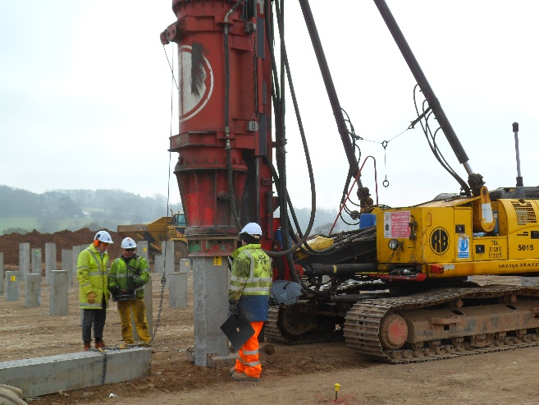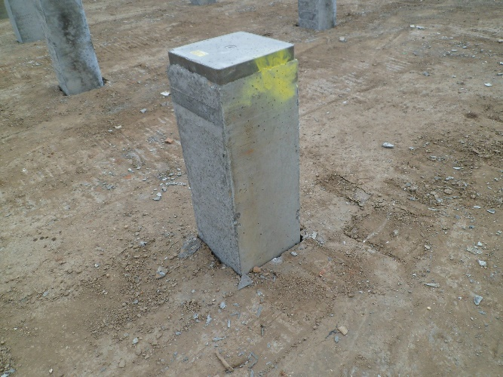
“As proven in the laboratory it is hereby confirmed that RoadCem is leading to visco-elastic behaviour. Visco-elastic behaviour leads to absorption of energy in the material, without the occurrence of cracks”
Research set-up into Visco-Elastic Behaviour
For the tests a single size sand (1780/m3) was used (fractions 0.5/1mm) in addition to 0.09% m/m RoadCem material in relation to sand, as well as 9.14% m/m OPC (CEM 1 42.5 N).
The OMC (optimum moisture content) at MPD (maximum proctor density) was 11% m/m.
The reference mixture was composed with 9,14 m/m OPC (CEM 1 42.5N) under equal conditions prepared without any RoadCem added.
The visco-elastic and ductility properties of RoadCem are found by conducting dynamic tests.
Dynamic Testing
These dynamic tests are carried out using non-destructive ultra-waves in order to determine the dynamic- elastic modulus. By means of destructive four-point bending tests in which repetitive loads at a fixed frequency are applied, a superior fatigue performance is confirmed.

By observing the longitudinal displacement mode after excitation, the dynamic modulus is obtained, as well as the dampening characteristics, which relate to the visco-elastic properties of the material being tested.
It is very clear that the pattern for cement treated stabilisation with added RoadCem (shown green) is showing a restrained vibration compared to the cement alone stabilised material (shown as red).
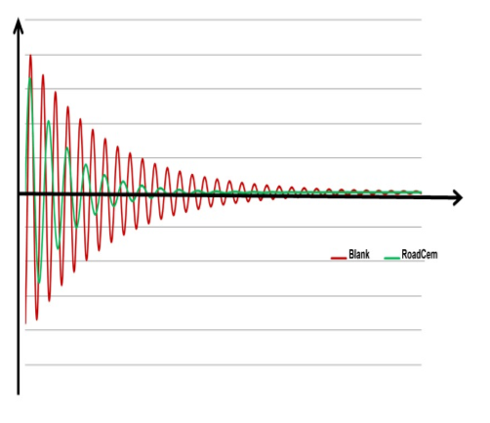
The above figure shows that vibration absorption with RoadCem shows a higher restrain and will be more resistant to impacts and foundation loadings.

100 repetitions 500 repetitions  strain dynamic modulus strain dynamic modulus The graph clearly shows that the RoadCem stabilised soil behaves as a visco elastic material  60 5574 60 5103  70 5569 70 5087  80 5553 80 5182  90 5560 90 5136  100 5537 100 5135  110 5526 110 5116  120 5495 120 5121  130 5453 130 5115  140 5416 140 5086  150 5394 150 5040  160 5372 160 5001  170 5349 170 4982  180 5331 180 4963  190 5310 190 4912  200 5272 200 4880 A traditional cement soil stabilisation without RoadCem will always behave as a rigid material. Rigid materials will normally break at a strain of 50-125 micro meter. Resulting in a steep decrease in Elastic modulus, when this breaking strain is reached. A visco elastic material such as a RoadCem soil concrete has a far higher breaking strain and the elastic modulus will reduce only gradually with an increase in value.  210 5248 210 4867  220 5223 220 4825  230 5199 230 4799  240 5175 240 4752  250 5150 250 4717  260 5126 260 4678  270 5114 270 4626  280 5087 280 4578  290 5056 290 4527  300 5027 300 4485  310 5004 310 4438  318 4978 320 4374  329 4952 330 4342  338 4910 340 4265  345 4877 350 4209  359 4779 360 4131  367 4662 370 3999  377 4574 380 3873  388 4441 390 3579  396 3819 400 3014 |  |  |  | 500 repetitions
 | 5574 |  |  | 60 |  | 5103
 | 5569 |  |  | 70 |  | 5087
 | 5553 |  |  | 80 |  | 5182
 | 5560 |  |  | 90 |  | 5136
 | 5537 |  |  | 100 |  | 5135
 | 5526 |  |  | 110 |  | 5116
 | 5495 |  |  | 120 |  | 5121
 | 5453 |  |  | 130 |  | 5115
 | 5416 |  |  | 140 |  | 5086
 | 5394 |  |  | 150 |  | 5040
 | 5372 |  |  | 160 |  | 5001
 | 5349 |  |  | 170 |  | 4982
 | 5331 |  |  | 180 |  | 4963
 | 5310 |  |  | 190 |  | 4912
 | 5272 |  |  | 200 |  | 4880
 | 5248 |  |  | 210 |  | 4867
 | 5223 |  |  | 220 |  | 4825 |  | A traditional cement soil stabilisation without RoadCem will always behave as a rigid material. Rigid materials will normally break at a strain of 50-125 micro meter. Resulting in a steep decrease in Elastic modulus, when this breaking strain is reached.  A visco elastic material sucha s a RoadCem soil concrete has a far higher breaking strain and the elastic modulus will reduce only gradually with an increase in value.
 | 5199 |  |  | 230 |  | 4799
 | 5175 |  |  | 240 |  | 4752
 | 5150 |  |  | 250 |  | 4717
 | 5126 |  |  | 260 |  | 4678
 | 5114 |  |  | 270 |  | 4626
 | 5087 |  |  | 280 |  | 4578
 | 5056 |  |  | 290 |  | 4527
 | 5027 |  |  | 300 |  | 4485
 | 5004 |  |  | 310 |  | 4438
 | 4978 |  |  | 320 |  | 4374
 | 4952 |  |  | 330 |  | 4342
 | 4910 |  |  | 340 |  | 4265

